SAD Stat
The Stat application is an API collecting statistics and storing it in a database and a GUI application searching and showing the information. It is a generic application which can be used for all UC:s applications.
The statistics collected is time statistics showing usage and response times for the services and customer statistics showing customer usage of the services.

Responsible Anders Persson
Department IT
Version 1.0
Date 2011-03-10

Table of contents
1 Overview 3
1.1 Scope 3
1.2 Purpose 3
1.3 Intended audience 3
1.4 Stakeholder representation 3
1.5 Viewpoint definitions 3
1.6 Relationship to other SADs 3
1.7 Process for updating this SAD 3
2 Architecture background 4
2.1 Problem background 4
2.2 Solution Background 4
3 Views 5
3.1 Scenario/Use case View 5
3.2 Functional View 6
3.3 Development View 8
3.4 Deployment View 8
3.5 Data View 10
3.6 Operational View 11
4 Referenced material 12

Overview

Scope
This is the solution architecture document for the Stat application. It describes the API, the internal structure and the GUI.

Purpose
The purpose of this document is to be the base for building, testing and deploying the system. It will also be an important information source for maintenance and extension of the system.

Intended audience
UC architecture board, developers, test leader, maintenance team. Partly also persons working with the deploy process and the infrastructure.

Stakeholder representation
Credit information responsible (which are interesting in the use of UC:s services).
UC architecture board.
UC operations responsible.

Viewpoint definitions
See [1]

Relationship to other SADs
N/A.

Process for updating this SAD
Standard UC process.

Architecture background

Problem background
From a marketing perspective, there is a need to know how the customers use UC:s services, which services, which products and even which times.
From an operational perspective, there is a need to be able to monitor the use of services and the response times of services, often in combination with a time perspective (for example compare response times two months, before and after an upgrade).

System overview
The system has three distinct parts:
- The database storing all statistics information, aggregated as much as possible.
- The API collecting information from the applications. The API is explicitly called from the applications.
- The GUI aggregating and presenting the information.

Goals and context
The goal is to provide system owners with information about system usage and operation personnel with information about response times. It is also a useful source for application performance improvement activities.

Significant driving requirements
These are the main architectural driving requirements:
- Failures in the API should neither cause the applications to fail, nor result in performance problems for the application.
- Performance impact on the applications should be low.

Solution Background

Architectural approaches
The API is a pure Java application using JDBC to connect to the database. The API aggregates information in memory for a time period. After that time period, the information to store is copied to a “store queue” and each thread performing a call to the API will store a few records. If there is a database failure, the storing stops and a new period of aggregation is started to avoid that all threads are stuck with trying to reach a not contactable database.
The GUI creates a (rather advanced) dynamic SQL query to aggregate and sort the information requested. As a consequence, all aggregation of the information is done within the database.

Views

Scenario/Use case View

View description
The scenario view describes the system from the user, human or machine, perspective.
Corresponds to the Scenario Viewpoint [1]

View packet overview
From the review of UCOrders2 (2010-11-09 done by Anders Persson) the following needs were collected:
- Statistics of call times. Both the total time and the time to call mainframe. Aggregation per hour, service and product (UC-typ).
- Statistics of the customers’ use of UCOrders2. The number of calls aggregated per day, customer, service and product (UC-typ).
These needs has been formalized and complemented with the writers (Anders Persson) experiences from statistics at other customers.
Customer statistics aggregation levels:
- Service (for example UCOrders2, SMS)
- Method (for example businessReport, individualReport)
- Origin (for example TaEnUC, SMS). For future extension in the case of UCOrders2 as this is not part of the parameters to UCOrders2.
- Media (for example XML, HTML, XML+HTML)
- Product (for example 410, 41, 3)
- Customer (for example 99K12)
- Date (for example 2011-03-10)
- Day of week (for example Monday). This is of course redundant with date but gives a possibility to aggregate information for week days and for example see which days in weeks are peak days or which customers use the systems in the weekend.
Customer statistics aggregated information:
- The number of correct calls.
- The number of invalid calls (customer failures, for example invalid input).
- The number of failing calls (technical errors on UC causing the failure).
Time statistics aggregation levels:
- Service (for example UCOrders2, SMS)
- Method (for example businessReport, individualReport)
- Origin (for example TaEnUC, SMS). For future extension in the case of UCOrders2 as this is not part of the parameters to UCOrders2.
- Media (for example XML, HTML, XML+HTML)
- Layer (for example presentation, logic and integration separating different layers in the application)
- Product (for example 410, 41, 3)
- Date and hour (for example 2011-03-10 15)
- Day of week (for example Monday). This is of course redundant with date but gives a possibility to aggregate information for week days and for example see which days in weeks are peak days or which services are used in the weekend.
- Hour of day (for example 15). This is of course redundant with date and hour but gives a possibility to aggregate information for hours of day and for example see which hours are peak hours.
Time statistics aggregated information:
- The number of correct calls.
- The number of invalid calls (customer failures, for example invalid input).
- The number of failing calls (technical errors on UC causing the failure).
- Total time for correct calls (give possibility to calculate average time).
- Total time for invalid calls (give possibility to calculate average time).
- Total time for failing calls (give possibility to calculate average time).
- The number of calls in the time range 0-10 ms.
- The number of calls in the time range 11-20 ms.
- The number of calls in the time range 21-50 ms.
- The number of calls in the time range 51-100 ms.
- The number of calls in the time range 101-200 ms.
- The number of calls in the time range 201-500 ms.
- The number of calls in the time range 501-1000 ms.
- The number of calls in the time range 1001-2000 ms.
- The number of calls in the time range 2001-5000 ms.
- The number of calls in the time range 5001-10000 ms.
- The number of calls in the time range 10001-20000 ms.
- The number of calls in the time range 20001- ms.
The number of calls gives a profile usable in combination with average times. It shows for example if there are many calls responding fast and a few with a very high response time (which it can be for example if a cache is used) or if all calls have about the same response time.
The GUI gives the possibility to filter the amount of data to for example a certain service and/or time period. It also gives the possibility to exclude uninteresting information which makes the level of aggregation higher.

View packets
The services will not be more thorough described in this document.

Functional View
Functional views describe how the system is to be structured as a set of interacting runtime elements.
Corresponds to the Behavioral Viewpoint [1]

View description
The functional view describes how the system is structured as a set of interconnected runtime components.

View packet overview

Statistics API
The statistics API works as follows (the time and customer statistics works in the same way):
- The information is aggregated in an in-memory structure. A HashMap is used where the key is an object with the aggregation levels and the value is an object with the aggregated information. This data structure is used for all updates with collected statistics information. Note that updating this structure will not require and database access. The main reason for this structure is:
- The API should be able to continue collecting data even if the database temporary does not respond.
- The in memory aggregation gives extremely fast response times and allows the collection of millions of calls per second. This is more noticeable the more information of the same kind that is collected. As a consequence, the API can be used for example within a loop without affecting the performance of the system noticeable (which had not been the case if each call would result in a call to the database). For systems with low throughput, this gives no advantage (the aggregation level is low), but on the other side it gives no disadvantage either.
- After a period of time (set to 60 seconds), the information in the HashMap is copied to a store queue (ArrayList). The copy is a deep copy which makes updates in the aggregation objects not affecting the objects in the store queue. Each thread calling a statistics collection method will get a small number (set to 3) of objects from the queue to store in the database. The following is done:
- The aggregation levels that have a corresponding dimension table in the database are looked up in a HashMap to find the corresponding id. If it is not found, it is created in the database and the whole HashMap is reread. Of course there is also failure handling if another instance in the cluster has already created the record in the database. The dimensions has been chosen in a way that makes inserts a rare situation and only shortly after deploy of the application which makes this strategy perfectly okay from a performance perspective.
- The aggregated information is updated in the database (SQL update). If the update did not affect any row, the information is created in the database (SQL insert). If that fails due to duplicate key (another instance in the cluster has already inserted the record), a new SQL update is performed. If that fails, it is considered in the same way as a database exception, see the description of error handling.
- The information in the aggregation HashMap is decreased with the stored information, and if the results are zero (meaning no updates has been done from when the information was copied to the store queue), the object is removed from HashMap.
- When the last object in the store queue is stored, a new period of only aggregation is started.
- If there is a failure, the storing is aborted and a new period of only aggregation is started. Observe that the information not stored when the failure occurs is still in the HashMap which means it will be stored the next time and no information is lost due to a failure.
At system shutdown, there may be a small amount of information not stored which is lost. To give a possibility to solve that, there is a flush method offered which may be called for example from the Servlet.destroy() method. Note that it must not be called during normal circumstances.
Note that thread safety is an important part of the solution. The whole data structure has to be consistent (not only the separate parts).

Statistics GUI
The statistics GUI works in the following way (the time and customer statistics works in the same way):
- A form with filtering and sort/aggregate options is presented. Database calls are performed to retrieve the information for the dropdown filtering options.
- From the filtering and sort/aggregation options, a (rather complex) SQL is created to retrieve the information. The aggregation and sorting is done in the database.
- Aggregation at group level (if chosen) is done in the application.
- The information is presented in an html table.

View packets
The functionality will not be more thorough described in this document.

Development View

View description
Corresponds to the Development Viewpoint [1]

View packet overview
The functionality is described in the functional view. For details, see the javdoc.
There is a thorough test suit to the API to test all situations.

View packets
For developer details, see the javadoc.

Deployment View

View description
Corresponds to the Allocation Viewpoint [1]

View packet overview
View packet #1 shows the logical deployment view.

View packets

View packet #1
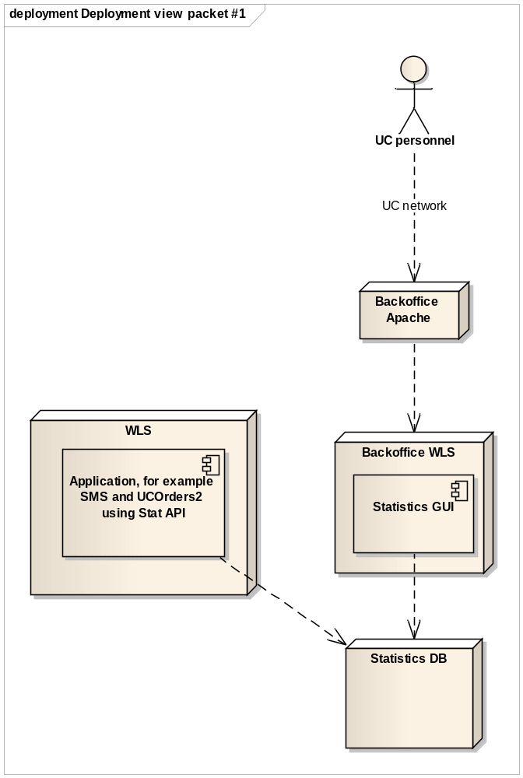
Figure 1: Logical deployment view

Element Catalog

Elements
The incoming structure with Backoffice Apache and Backoffice WLS is default UC structure and will not be discussed further.
The Application will use the Stat API to call the statistics database, which is an Oracle database.
The statistics GUI application will use the statistics databases.

Relations
See Figure 1.

Interfaces
Default Oracle database communication will be used as technical interfaces.

Data View

View description
Corresponds to the Data Viewpoint [1]

View packet overview
View packet #1 describes the database model.

View packets

View packet #1

Primary Presentation
This section presents the database model from a high level perspective.

Element Catalog
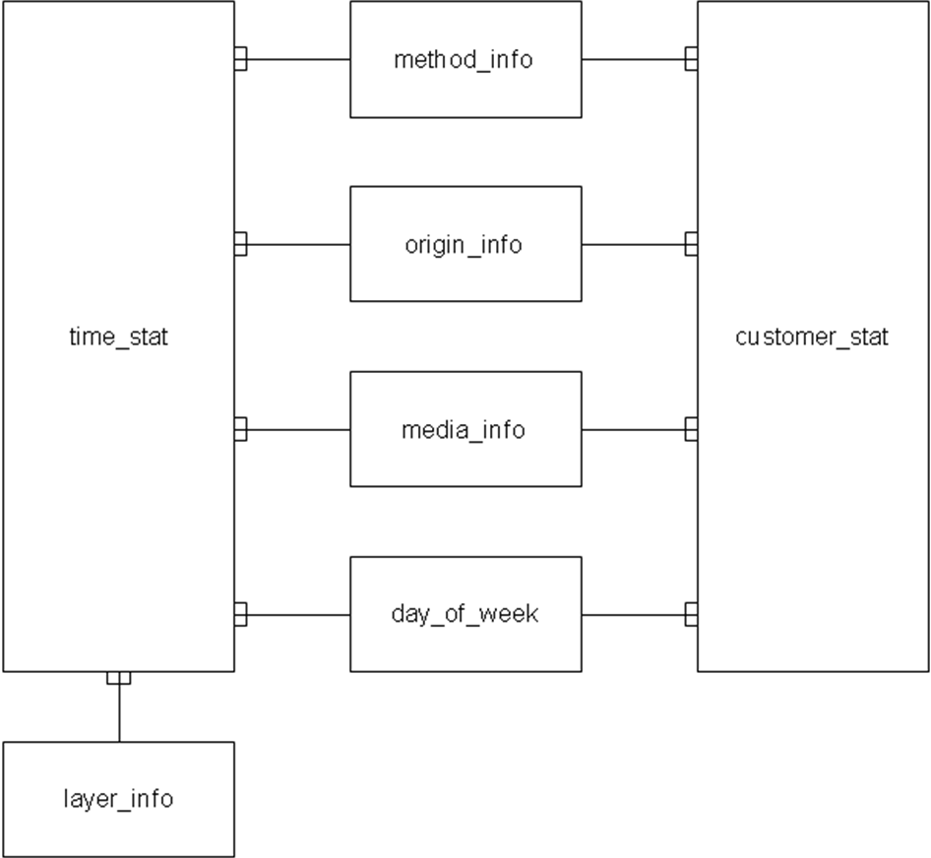
Figure 2: Database scheme

Elements
Time_stat respective customer_stat are the tables containing aggregated statistics information.
The five dimension tables are used to characterize some dimensions of the information.
Product and customer are not represented as dimension tables. The reason for that is that those dimensions are given in the service calls by the customers. They can be extremely many and they can be invalid given which makes them “less interesting” to put in a specific table.

Relations
See Figure 2.

Operational View

View description
Corresponds to the Operational Viewpoint [1]

View packet overview
If errors occur in the API, they are written in a log file.
The application is designed to be able to treat as a “black box” without a need for operational support. As long as the database is available and not full, the API will be “happy” and perform its job.

Referenced material
[1] UC Viewpoint Definition by Anders Heintz

